5 Fashion Brands Doing the Culture Proud With Their African Inspired Pieces
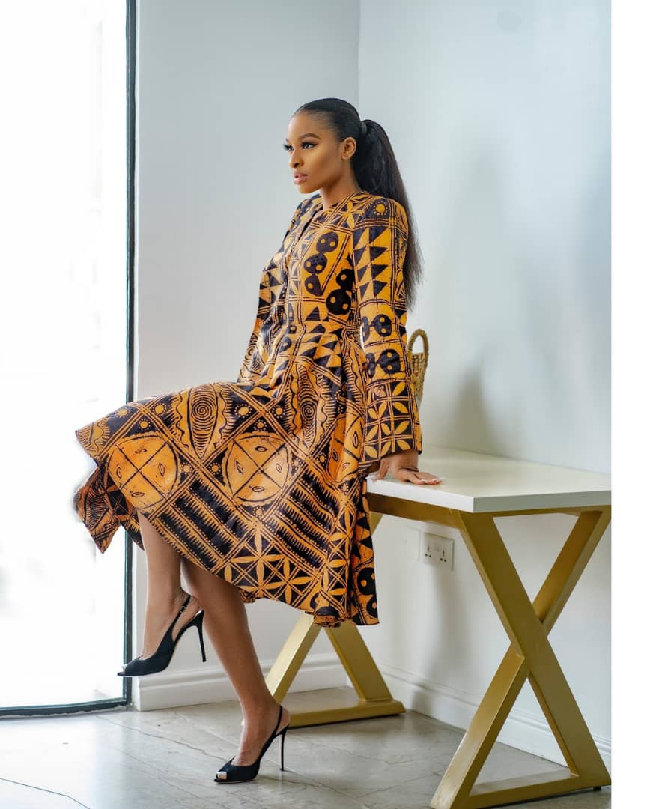
The Nigerian fashion industry has come of age. It blossoms with young, vibrant designers who are exploring the endless possibilities of fabrics and textures and making them into creations that make us gasp in awe.

Amid a wavering economy, the country is blessed with designers who are creating their narratives, pursuing their passions, and sticking to their stories, and the Nigerian fashion scene testifies of their stories. Stories that inspire the next generation of fashion designers to thrive.

In today's article, we look at 5 faves who are taking creativity to the next level.
Colourful. Ethnic. Bold. Authentic. Rich - these are the words that describe the handiworks of these designers.

Abiola Olusola Official

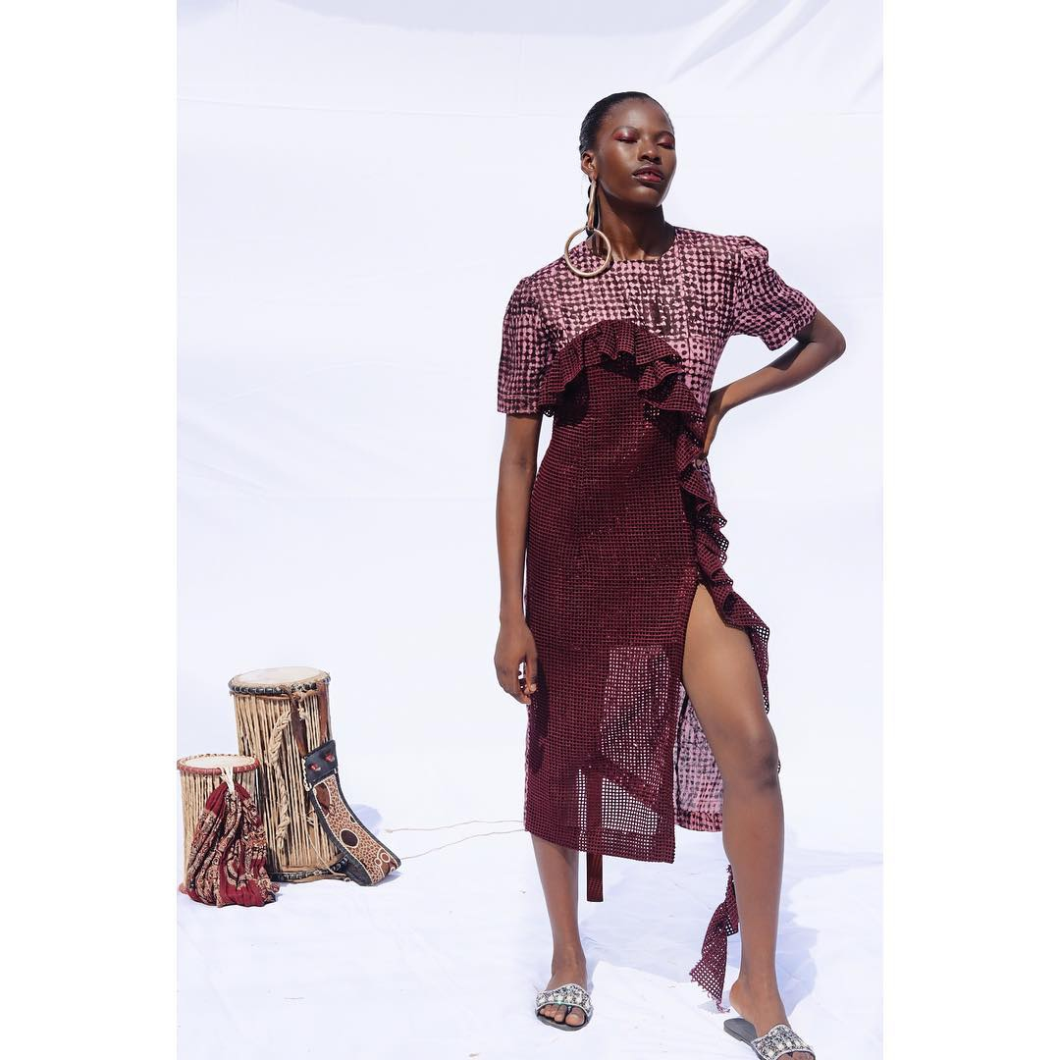

Founded in 2017, Abiola Olusola Official is focused on today’s contemporary African women. A Lagos-based eponymous label, it boasts of a contemporary women’s ready to wear and bespoke brand with a distinct juxtaposition of minimalist cuts, sleek architecture and African sub cultures and craftsmanship.

Abiola Olusola’s pieces are characterised by rich hues, minimalistic aesthetics, femininity, functionality and effortlessness that all come together to create timeless wears that represent the african woman.

Made in Lagos, Nigeria and founded by Abiola Adeniran Olusola - a Nigerian born and raised BFA graduate of fashion design from Instituto Marangoni Paris - this clothing brand is making our heads swell with pride and inspiration.

Take a look at her 2021 collection here

Fruché

When you have a mix of traditional Nigerian culture, heritage, artisanal techniques, and modern design, infused with indigenous sensibilities for the progressive Nigerian woman who isn’t afraid to take risks, the result is Fruché.

Fruché, a combination of the founder’s English and Igbo names: Frank and Uche, was founded in 2014 by Frank Aghuno. Fruché is a contemporary ready-to-wear womenswear brand that is committed to telling progressive stories of the Fruché woman. According to Frank, The Fruché woman is “free spirited, adventurous, and full of depth and committed to living her best life.”

Born and raised in Lagos, Frank, a self taught designer, draws his inspiration and knowledge from his mother, a former fashion designer through whom he first learned fashion.

Maxvive
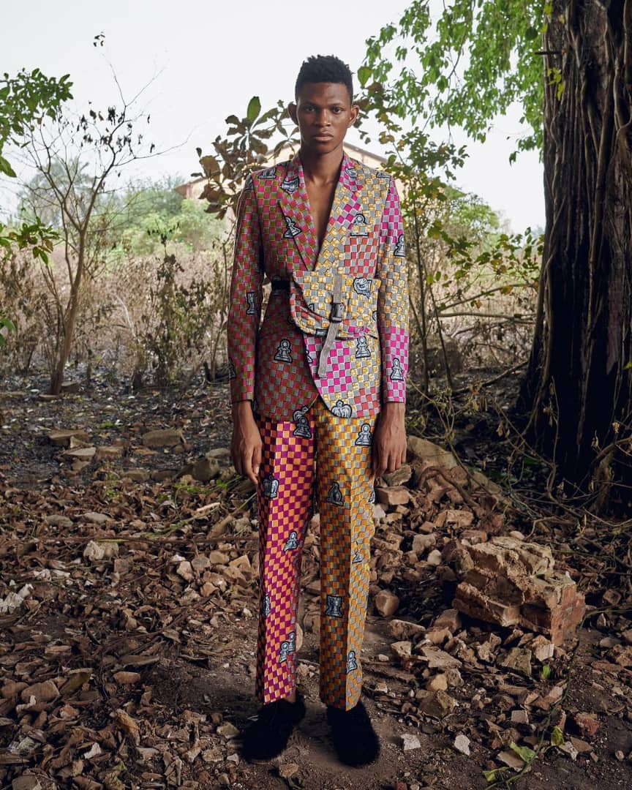

If, like me, you often roll your eyes at the western adaptation of the fashion seasons in Africa - talk about spring/summer and autumn/winter - you would find Maxvive a breath of fresh air.

Maxvive, a Nigerian based menswear label, is stirring conversations and challenging fashion seasons and gender norms through its minimalistic and androgynous innovative designs.

Thigh high socks boots, sequined trousers, bright pink agbadas, floral embellished pants are some of the boundary breaking pieces you would find in his collections.

Founded 12 years ago by Papa Oyeyemi at the age of 15, Maxvive is breaking grounds and shifting perspectives.

Cynthia Abila

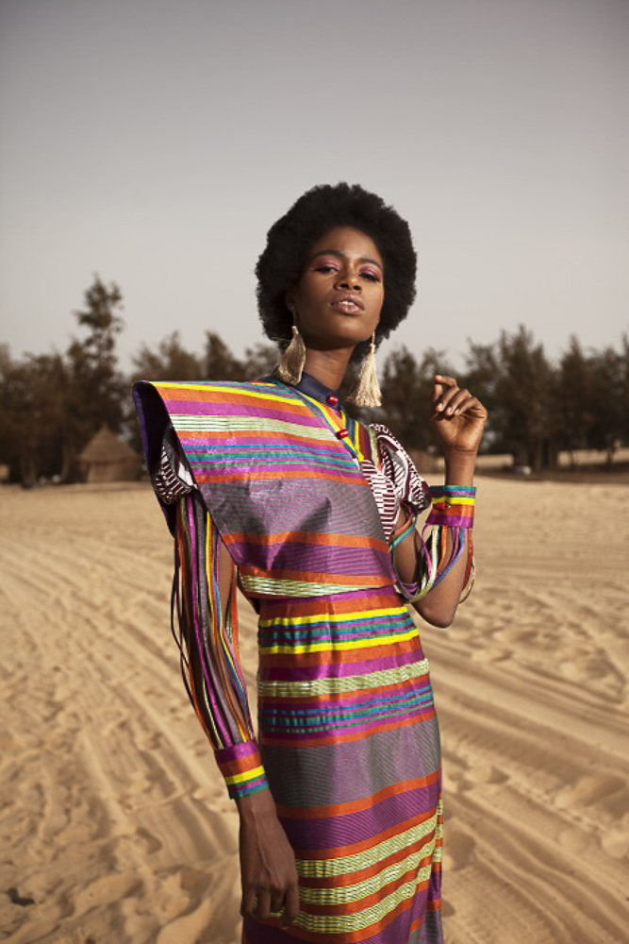

From elegant to minimalistic to ethnic chic, Abuja based Cynthia Abila is made for the fashion-conscious woman who explores the world beyond her walls and yet holds passionately to her roots.

A scroll through Cynthia Abila’s Instagram page and you’re met with elegant designs that tell stories of traditions, ethnicity and black history through bold colours, friendly textures and intricate patterns. Its 2021 collection features a range of exciting quality hand woven fabrics with rousing colours and textures predominantly made out of silk and cotton.

Cynthia Abila was founded in 2016 by Cynthia Otiyo-Abila. The brand aims to fuse different cultural and modernistic elements to create a remarkable style.

The LadyMaker

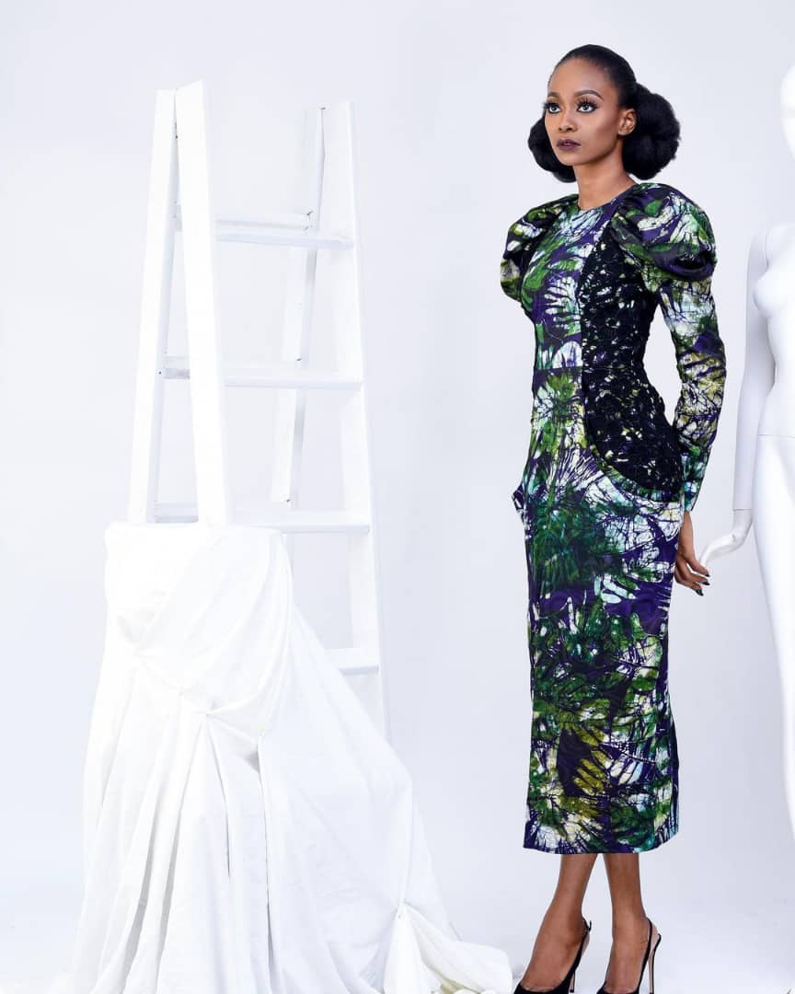

The lady is elegant, graceful, and brave; she wears sophisticated dresses that depict her style and class, and isn’t afraid to show them off. With foundational pieces inspired by African heritage for the modern woman, The LadyMaker is catering to the fashion needs of the stylish lady.

The LadyMaker is a womenswear brand whose design philosophy comes from a desire to create classic pieces that form a part of the foundation of a woman’s wardrobe.

The Lagos based fashion brand was founded in 2015 by Ifeyinwa Azubike, a lawyer turned fashion designer with a training from Istituto di Moda Burgo (Lagos Campus), The LadyMaker has developed a core aesthetic of marrying inspiration from the heritage of the continent with a focus on form, structure, elegance and the unexpected.

We’ve got lots of amazingly talented fashion designers in Nigeria who keep wowing us with their creativity and innovation. We haven’t covered them all - in fact we are just scratching the surface - but thankfully, we’re not stopping anytime soon.

