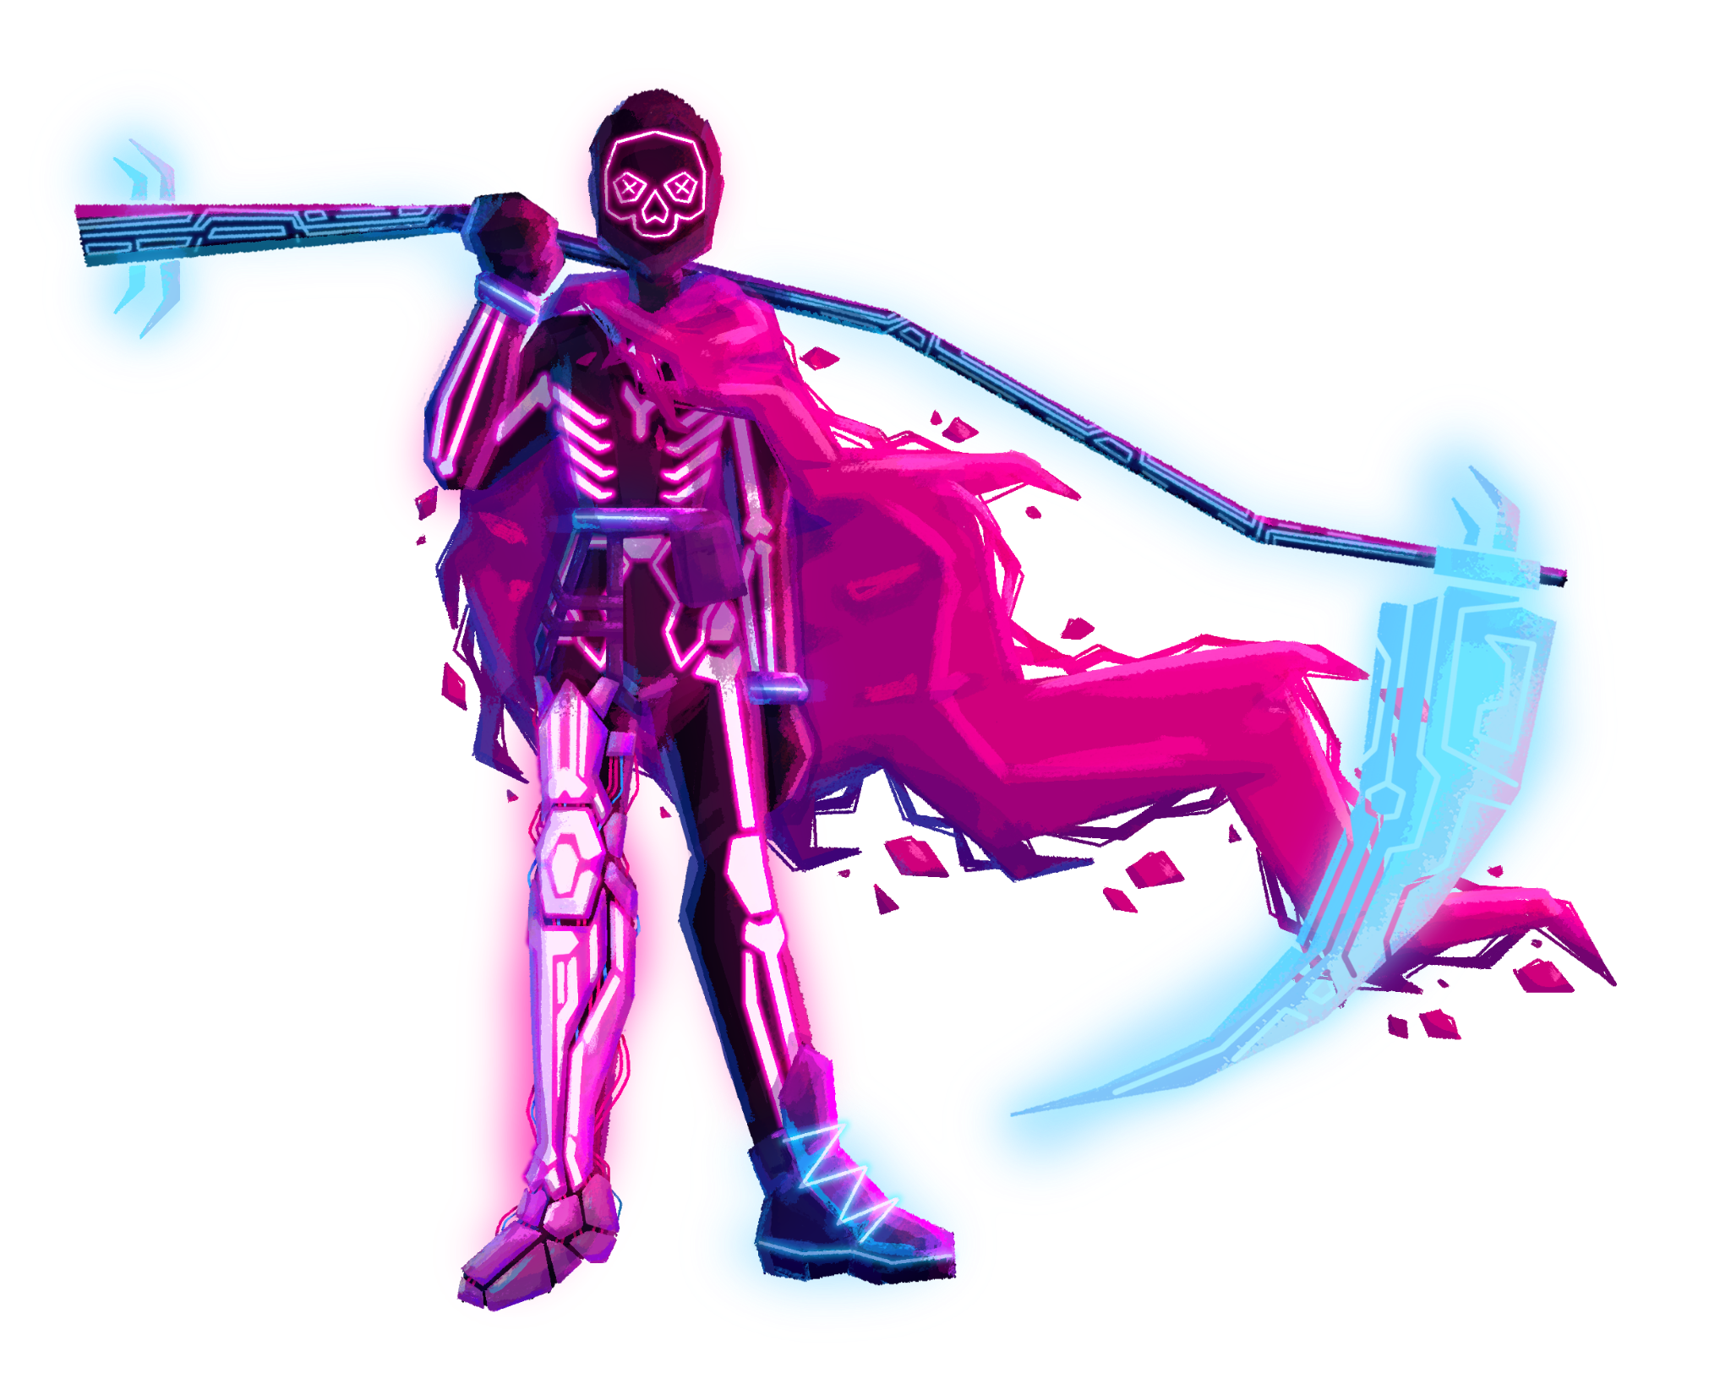Cyber-Death
Design Document

Team Roster:
Kyle Grenier - Lead Programmer
Michael Gonzalez - Art / Sound
Tristan Blair - Programming / Design
Anthony Pollos - Design / Production
Avery Macke - Art / Particle Systems
Cyber-Death
High Concept:
You play as Cyber-Death, and are tasked with reaping the mechanical souls of countless expired robots in a neon, virtual city. use your Scythe-Saber, to hack and slash through hordes of endless enemies in fast, engaging melee combat. Slice through enemies and watch them explode into a mess of mechanical parts that pile up on the battlefield! I mean, you’re friggin’ Cyber-Death, come on, act like it!

Summary:
In Cyber-Death, you play as the character of the same name, tasked with eliminating and collecting the souls of robots in a neotopia city environment. Wielding a scythe, Cyber-Death will go from wave to wave defeating hordes of robotic foes and collecting resources to exchange at the shop at the end of each round. Each round will become exponentially harder than the last, and collecting the resources dropped from fallen robots will be essential to surviving the longest amount of time.

Game Mechanics:
The combat of the game will generally feature a single one-two-three swing of your scythe to eliminate the robotic horde (Stretch Goal: Throwable scythe that boomerangs back to you). The movement will be simple, aswell. The player will experience extremely tight and snappy controls that will instantly respond to the player’s input. A simple dash mechanic will be implemented, aswell, having a very short duration of invulnerability during the dash, allowing the player to quickly dash in, attack a wave of enemies, and dash back to safety.
Each wave in the game will contain more and more robots to fight in addition to them having slightly higher health pools. Since the player will be upgrading their individual stats, the waves will exponentially increase in difficulty.
Robots defeated will drop scrap, the “money” of the game, allowing you to upgrade your equipment and stats at the shop. Dropped scrap must be collected by the player by walking over it before a certain amount of time depletes, in which the scrap will disappear and will not be collected by the player. This further encourages the player to always be moving around and narrowly avoiding the robots as they swing their scythe and collect scrap for the end of the wave.
After “x” amount of waves, certain new areas of the map will be accessible to the player, similar to how other horde-based games have unlockable areas after “x” conditions are met. These new areas will introduce new places for the robots to spawn in addition to a high ground location for both the player and enemies.

The shop will be accessible at the end of each wave/round. Located in the bottom right corner of the map, the shopkeeper will greet the player and offer upgrades to help them continue their onslaught. Various upgrades will be available in the form of “modules”, such as speed, attack speed, HP, attack power, damage reduction, and range of the scythe. These upgrades will cost a certain amount of resources, with the price increasing the more of a certain module you purchase. Buying multiple of the same module will in addition grant a slightly less powerful upgrade (If speed module 1 offers you a 10% speed boost, speed module 4-5 will offer a 4-5%, for example). (More info @ https://docs.google.com/document/d/1gjOKbNPc05hlGmMlObMF2kucHxkTuuj1xrBUtkRcJus/edit?usp=sharing)

Characters:

- Cyber-Death
  - The playable character. Wielding a neon death-scythe, Cyber-Death is tasked with eliminating all robots that stand in their way. They don't say much, because they don’t need too; the scythe does all the talking 😎

- Robots
  - The robots will be very simple in design, and will appear to be one-dimensional with little to no fanfare. They will have one basic slash attack and will progress towards the player at a set pace. Each wave will spawn additional robots
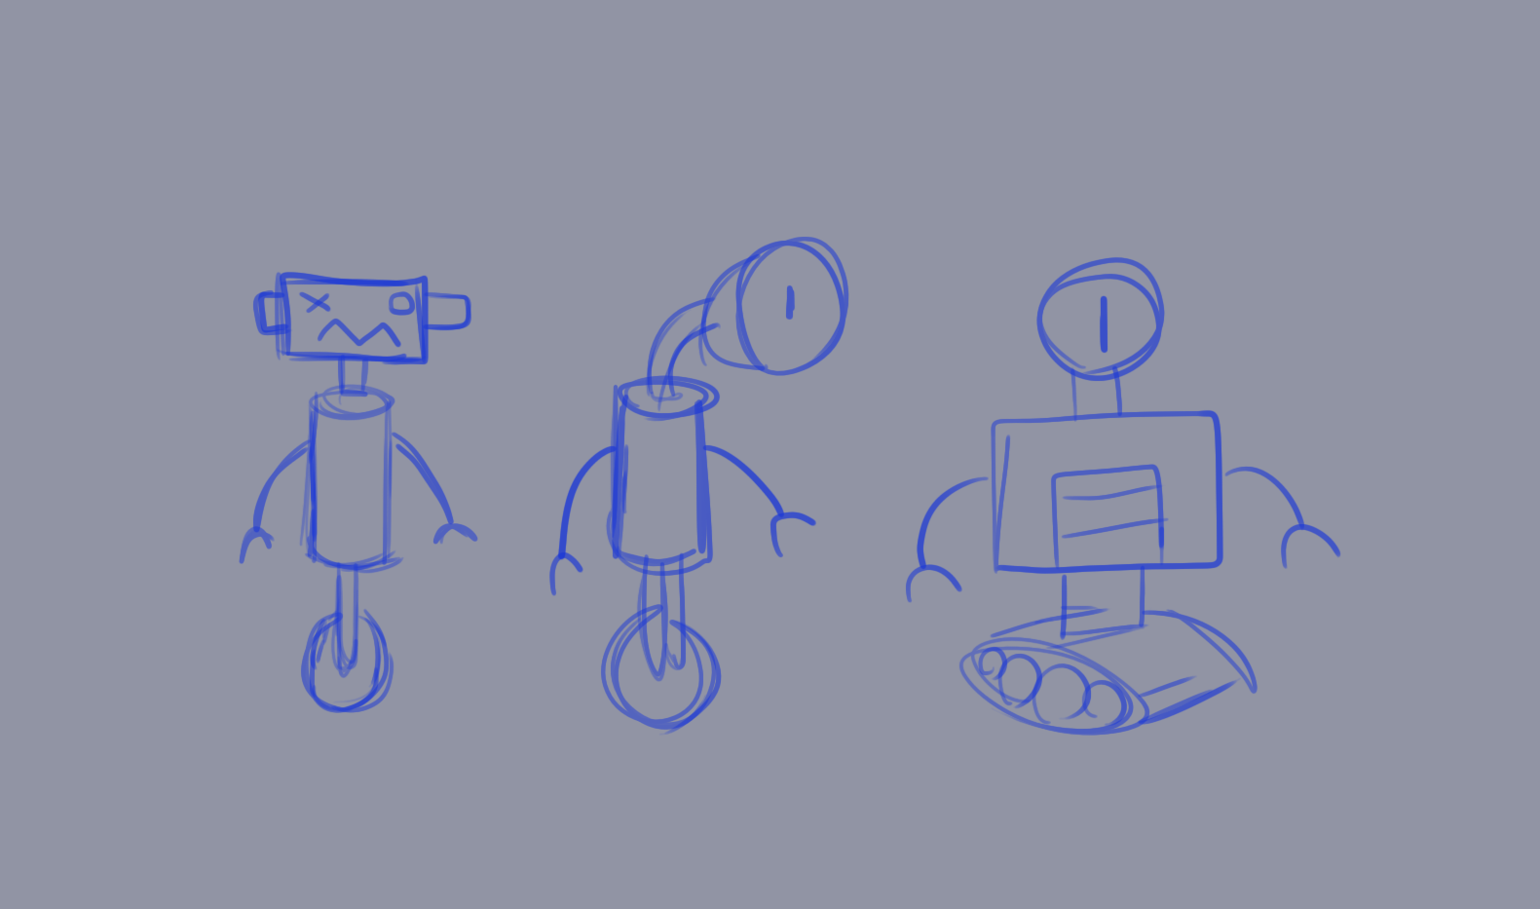(Not final concept art, replace later)
- Shopkeep
  - The owner of the shop in the alley, this lovable character will offer up small-talk and powerful modular upgrades to the player. Overall a lovable owner of a small shop who just wants everything to go back to normal
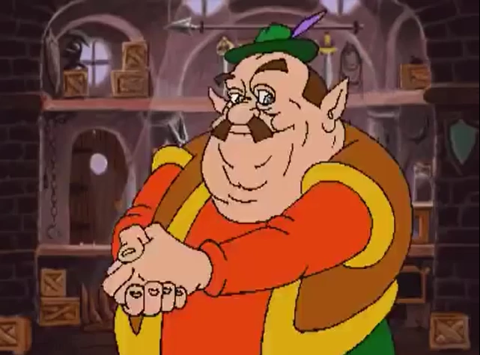(art for SURE not final, replace later!)

Environment:
The environment will be your basic neon tron inspired local. Large neon lights and dark buildings will flood the streets, with bright futuristic assets scattered around the map.
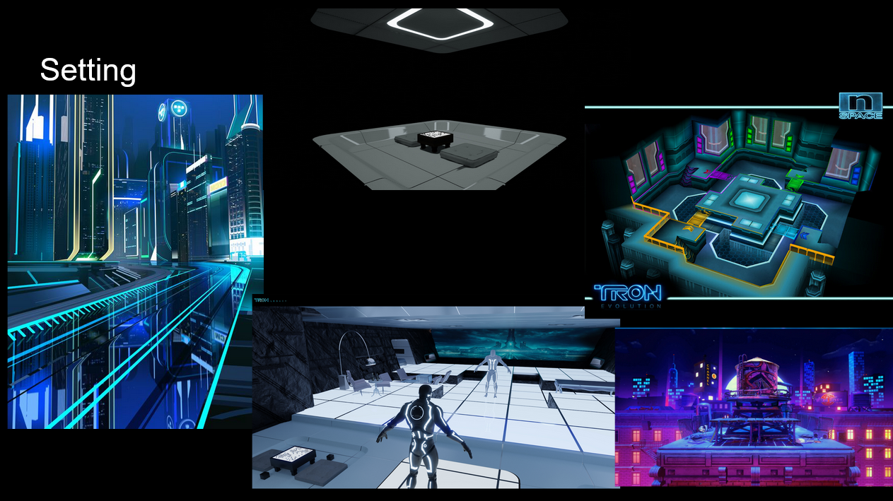

Level Ideas:
The core level will be on one two story plane, with an isometric view of the stage. The stage will appear diorama-like, with a set camera angle. The camera will only move where the player moves, whilst still being at that set camera angle.
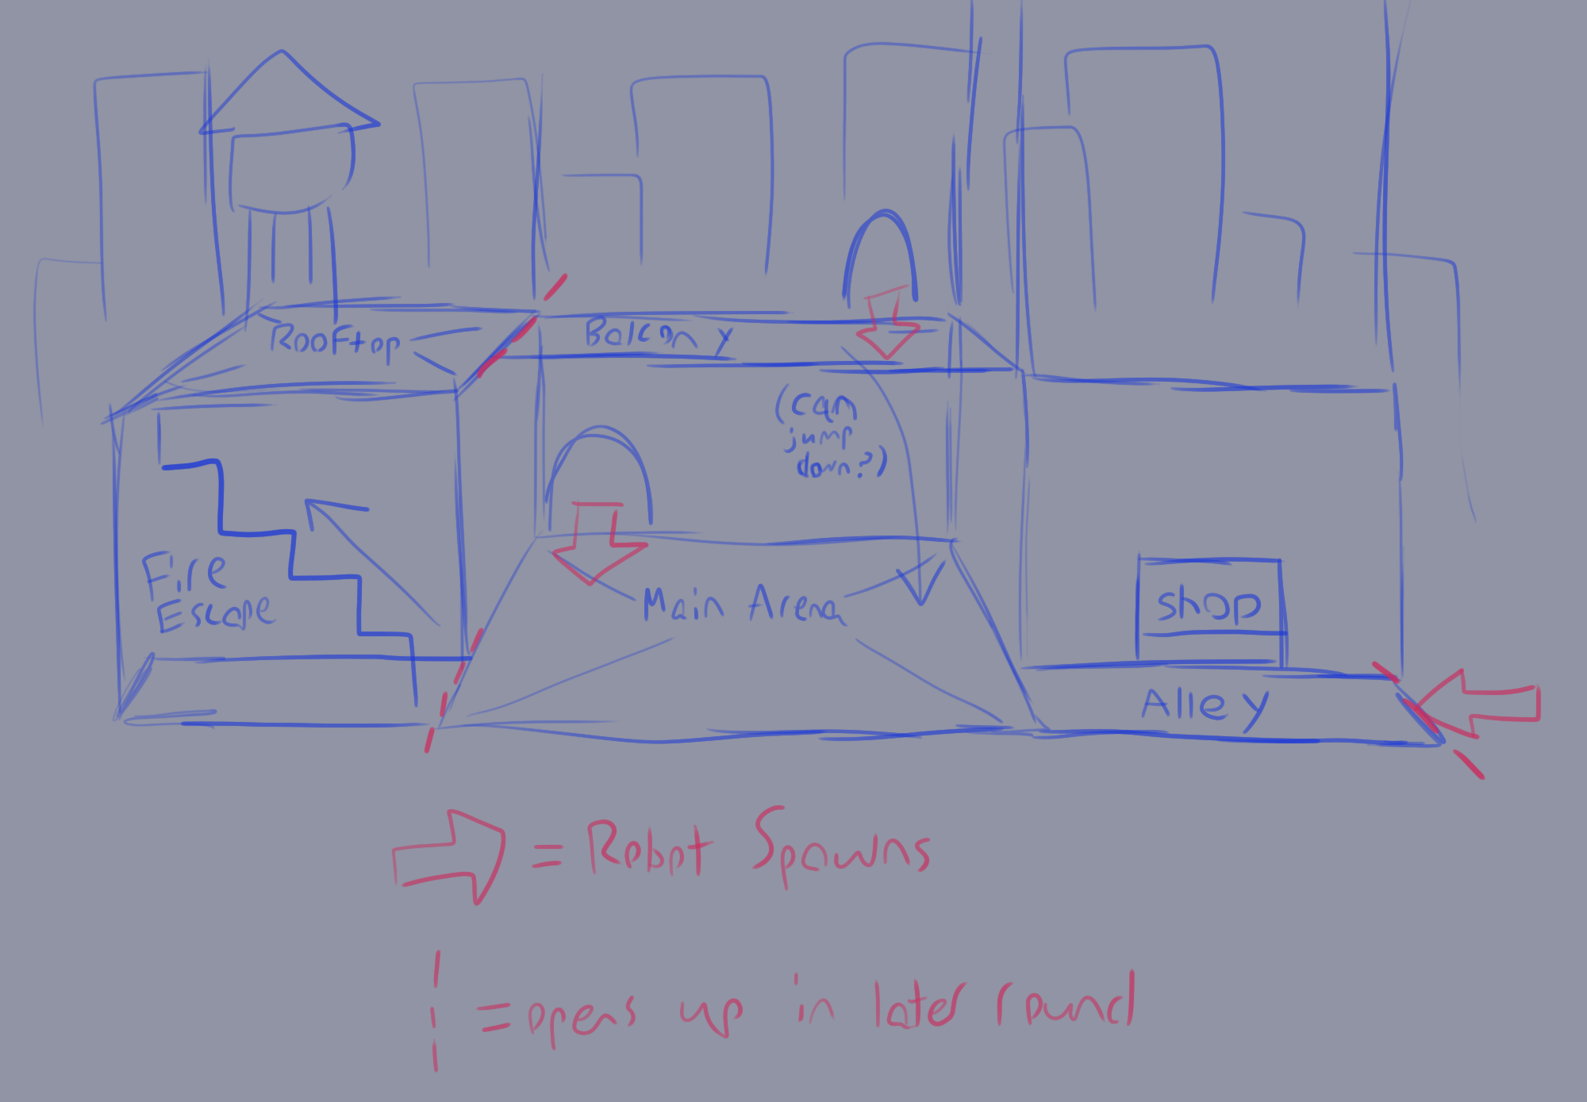

Controls:
- WASD
  - Basic Movement (Hades, enter the gungeon)
- Left-Click
  - Swing scythe
  - (Stretch goal) Repeatedly hitting left-click will perform a 1-2-3 swing (Marth Side-Special from Smash, Dark Souls swing, etc)
- Right-Click (Stretch-Goal)
  - Hold to fill a quick meter, and release to throw your scythe, dealing damage to any enemy that encounters it (Bone club from Binding of Isaac’s character The Forgotten)
- L-Shift
  - Very simple dash mechanic, advance towards the direction you are facing and gain a very small moment of invulnerability during the dash) (Cuphead dash, dark souls roll)
- E
  - Enter the shop (When standing in front of the door in between waves)

